Mt Buller Village VEHICLE POLICY – WINTER 2018
Driving in the Mt Buller Village can be dangerous, as the roads can still have a film of snow or ice even after they have been cleared. Therefore the following recommendations and conditions apply to anyone seeking a Winter 2018 Village permit:
- Consider completing a training program on driving in snow and icy conditions.
- Watch the attached video prepared by Snowsafe Australia on snow safe driving.
- You must have Mud & Snow tyres as a minimum, which have the M+S symbol shown below. Snow tyres provide even better traction and are highly recommended. These are specifically made for snow and have a standard mountain / snowflake symbol.
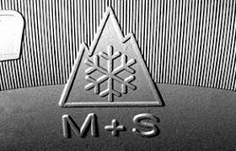
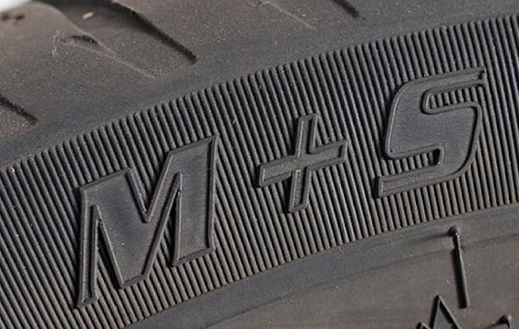

- If your vehicle is diesel, fill up with alpine mix before arriving to avoid your fuel solidifying.
- Use brakes gently and drive slowly. Accelerate gently to avoid wheel spin and avoid unnecessary gear changes. Use first or second gear on level ground before ascending or descending hills.
- If you lose traction, try to control your car by steering rather than braking.
- Your vehicle must:
- be able to be fitted with wheel chains;
- carry appropriately sized, diamond wheel chains;
- only be driven by people who know how to fit these wheel chains and who have the ability to drive safely on snow & ice-covered roads;
- only be driven between the mountain carparks and your accommodation / allocated parking spot;
- not be driven around the village (eg visiting, shopping, dining, race club, ski school);
- not be used to transport guests and their luggage to & from the carparks;
- not remain within the village for more than 30 minutes (only applies to Village Access permits);
- be parked in one of the designated overnight carparks (Hell Corner, Tip Corner, CSIR Lower) if it has a Village Access permit or your allocated parking spot is unavailable.

VILLAGE PERMIT DECLARATION - WINTER 2018

I confirm that my vehicle is a 4WD or AWD with ground clearance of at least 185 mm, and that when within the Mt Buller Village it will:

Be fitted with either Snow tyres or M+S tyres with adequate tread depth (as per owner's manual).

Contain appropriately sized diamond wheel chains

Only be driven by people who know how to fit these wheel chains to my vehicle and who have the ability to drive safely on snow & ice covered roads

Only be driven between the mountain carparks and my accommodation / allocated parking spot

Not be driven around the village (eg visiting, shopping, dining, race club, ski school)

Not be used to transport guests and their luggage to & from the carparks

Be parked in one of the designated overnight carparks (Hell Corner, Tip Corner, CSIR Lower) if my allocated parking spot is unavailable

If Village access Permit:

Not remain within the village for more than 30 minutes

Be parked in one of the designated overnight carparks (Hell Corner, Tip Corner, CSIR Lower) if it has a Village Access permit or my allocated parking spot is unavailable

I acknowledge that I have read, understood and agree to abide by the terms, conditions and requirements for a village permit. I understand my permit may be cancelled without notice or refund if anyone driving my vehicle breaches any of the conditions or fails to obey all lawful speed and other road rules or instructions.

Site Name |  | Vehicle
Permit Holder |  | Registration Number
Signature

This declaration must be completed and returned with payment in order to receive your permit. Permits will not be issued if the declaration is not returned.

